**SOLUTION TO ASSIGNMENT**

As a hired data engineer at Fufu Republic, the dimensional model developed to address the business's needs for data-driven decision-making is shown below:

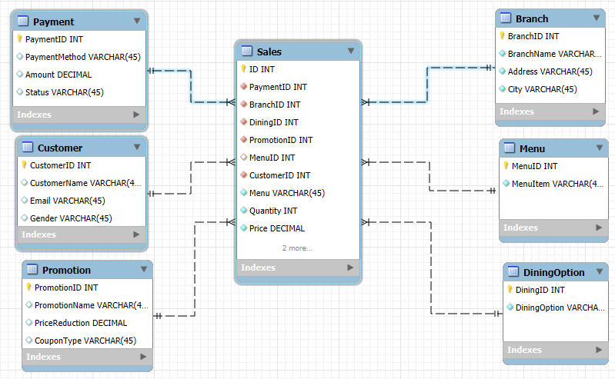

**A business process identified is the Sales Business process**

Some of the business questions under the sales business process are listed as follows:

* What are the sales that is generated across the different branches?
* What are the sales generated across the different items?
* Are we meeting up with the daily, monthly, quarterly and yearly sales across all branches and for all the item?
* Why are we generating more/less sales in a particular branch?
* Why are we generating more/less sales for a particular item?
* What kind of improvement do we have to make to generate more sales in branches that are underperforming?
* Are the set-up promotion and discount yielding the desired sales?

From the model diagram above, we have a start schema model diagram where the fact table is the sales and the dimensions table are the payment, customer, promotion, branch, menu and dining option tables.

The model diagram will help to understand sales trends across the different locations, payment methods, and the various dining options. You will be able to track and take records of sales as it affects the various locations, payment method and dining options and make informed decisions. The model can also help to track purchasing habit of customers and the impact of the of the set up promotion